UNIVERSITY OF INFORMATION TECHNOLOGY  COMPUTER ENGINEERING DEPARTMENT | MID-TERM EXAMINATION II (2018-2019)  COURSE: DEGITAL LOGIC DESIGN  Time duration: 90 minutes  (Paper materials are allowed)
STUDENT NAME: ……………………………………ID: …………..ORDER:…

Question 1 (3 points)
Design 1M x 8 RAM using 256K x 1 RAM chips

Question 2 (3 points)
Derive the minimal-state FSM from the state/output table shown in below table:
Present  state | Next state |  | Output  Z
 | W = 0 | W = 1
A | B | C | 1
B | D | F | 1
C | F | E | 0
D | B | G | 1
E | F | C | 0
F | E | D | 0
G | F | G | 0

Question 3 (4 points)
For the state diagram shown in below figure, derive the state encoding using the prioritized-adjacency heuristic:
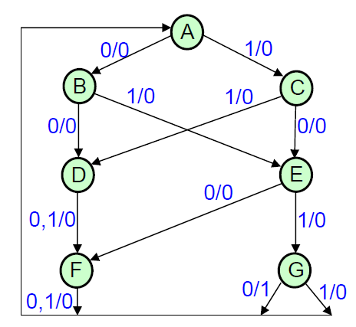

This examination’s learning outcomes (LO) (matching to subject syllabus’s LO)
Question | LO | Description
1 | G1.2 | Be able to design the data path
2 | G1.1 | Be able to analyze the finite state machine
3 | G3 | Be able to read the reference books

Approved by Head of Subject Designed by
Lâm Đức Khải Lâm Đức Khải

